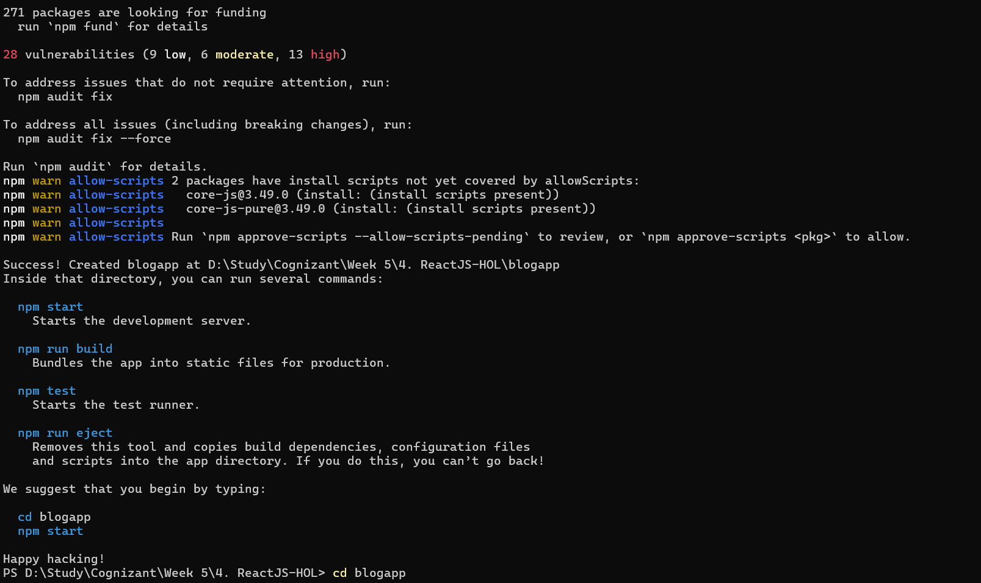
App.js

import Posts from "./Posts";

function App() {
return (
<div>
<Posts />
</div>
);
}

export default App;

Post.js

class Post {
constructor(id, title, body) {
this.id = id;
this.title = title;
this.body = body;
}
}

export default Post;

Posts.js
import React from "react";
import Post from "./Post";

class Posts extends React.Component {

constructor(props) {
super(props);

this.state = {
posts: []
};
}

loadPosts() {

fetch("https://jsonplaceholder.typicode.com/posts")
.then(response => response.json())
.then(data => {

const posts = data.map(post =>
new Post(
post.id,
post.title,
post.body
)
);

this.setState({
posts: posts
});

});

}

componentDidMount() {
this.loadPosts();
}

componentDidCatch(error, info) {
alert(error);
}

render() {

return (
<div>

<h1>Posts</h1>

{
this.state.posts.map(post =>

<div key={post.id}>

<h3>{post.title}</h3>

<p>{post.body}</p>

<hr />

</div>

)
}

</div>
);

}

}

export default Posts;
